Assume that you are a senior prompt engineer and you have to write a prompt for anitgravity so it could replicate this and. You can update this docs as you by the process
and i have to deploy it on vercel so use the coding language as per that
MAKE SURE YOU LEAVE NO ERRORS IN PLANING AND GENERATING A PROMPT

I am making as i want to create same platform deploying certificates

{
# Goal : to create replecate of NPTEL Crefication verification

# From NPTEL course
Roll No:NPTEL24CS118S1053101145

Task 1: when the QR is scanned it should point to url like this
- https://archive.nptel.ac.in/noc/Ecertificate/?q=NPTEL24CS118S105310114504042426
#and there will be a plain static web page which will consists of a button
-> action after clicking the button Course Certificate can be view



- It should redirect to url like this
https://archive.nptel.ac.in/content/noc/NOC24/SEM2/Ecertificates/106/noc24-cs118/Course/NPTEL24CS118S105310114504042426.pdf

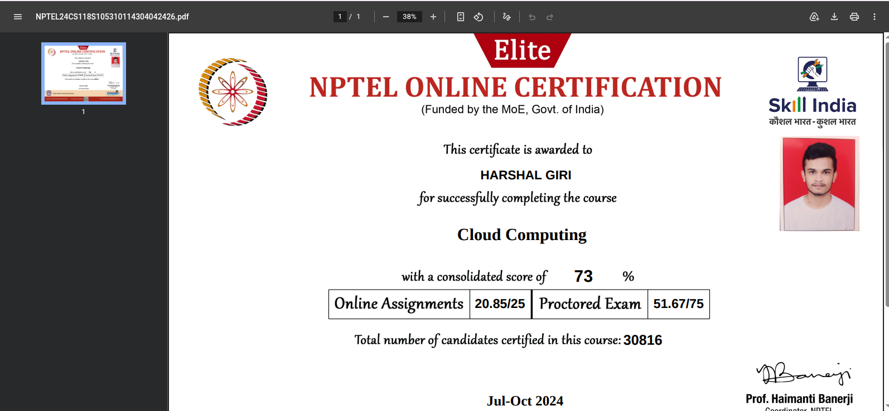
Fig: this will be displayed it is a image converted to pdf

NOTE: For now we will keep the page empty but have to display pdf over there

}

{
Additional knowledge for you if it may help :
There is no officially public full breakdown format from NPTEL, but based on common NPTEL roll number patterns, this is most likely structured like this:
Part | Meaning
NPTEL | Platform/Certification system
24 | Year of exam/session → 2024
CS | Subject domain/course category → likely Computer Science
118 | Internal course ID/code
S | Semester/session identifier (often Jul-Dec or specific slot)
1053 | Exam center / region / batch code
101143 | Unique candidate identifier

}

This is the certificate to upload and there are multiple such certificates
